Subject Name: **Source Code Management**

Subject Code: **24CSE0106**

Cluster: **Alpha**

Department: **DCSE**



Submitted By: - Submitted To: -

## Kushal Dr. Mudita

2410990313 Department Of Computer

G-4 Science & Engineering

Chitkara University Institute Of

Engineering And Technology, Punjab

**INDEX**

|  |  |  |  |
| --- | --- | --- | --- |
| **S. No.** | **Program Title** | **Page No.** | **Sign** |
| **1.** | **To install and configure Git Client on your local system.** |  |  |
| **2.** | **Setting up GitHub Account and Adding Collaborators on GitHub Repository.** |  |  |
| **3.** | **To merge two branches within a Git repository.** |  |  |
| **4.** | **To demonstrate push and pull operations in Git.** |  |  |
| **5.** | **To demonstrate forking, cloning and pull requests.** |  |  |
| **6.** | **To manage ignored files and creating structured README files.** |  |  |
| **7.** | **To simulate and resolve merge conflicts.** |  |  |
| **8.** | **To automate development processes using GitHub Actions.** |  |  |
| **9.** | **To integrate all Git concepts into a comprehensive team project.** |  |  |

# Practical No.: 1

**Aim:** To install and configure Git Client on your local system.

## Theory:

Git is a distributed version control system designed to handle everything from small to very large projects with speed and efficiency. It allows multiple developers to work on the same project

without conflicts by maintaining a history of all changes made to the code.

Version control systems like Git help developers track changes, revert back to previous versions, and collaborate efficientl**y** on projects. Git stores data as snapshots, allowing developers to switch between different versions and branches of a project effortlessly.

## Procedure:

1. Download Git from <https://git-scm.com/> by clicking ‘Download for Windows’ option in the computer screen graphics.

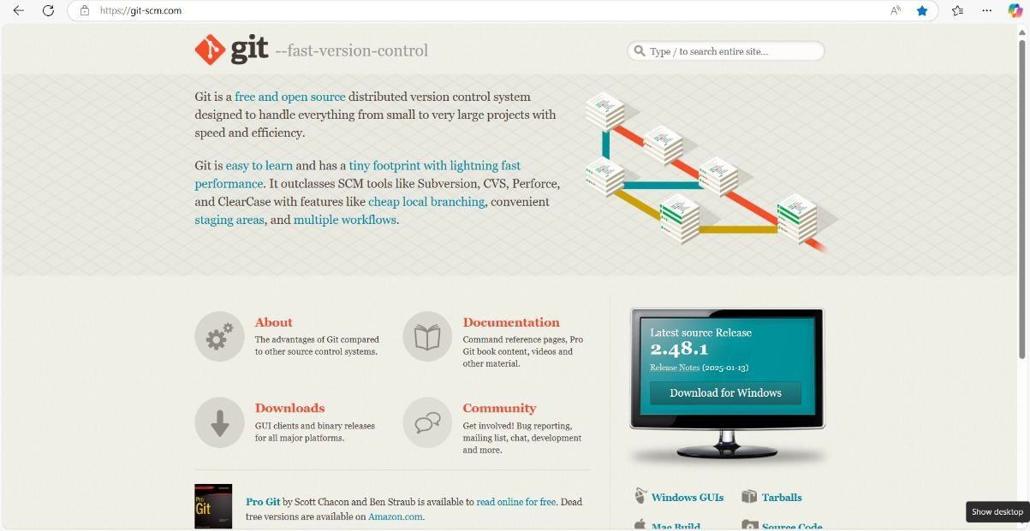

1. Git installation wizard steps.
2. Click on Next followed by many other next.

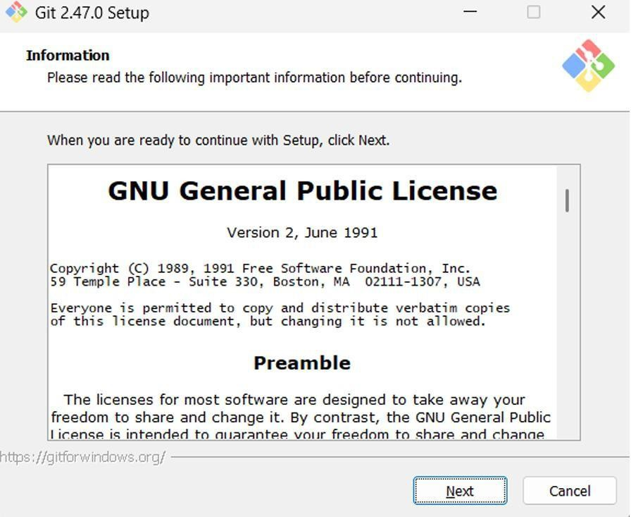

1. Click on install.

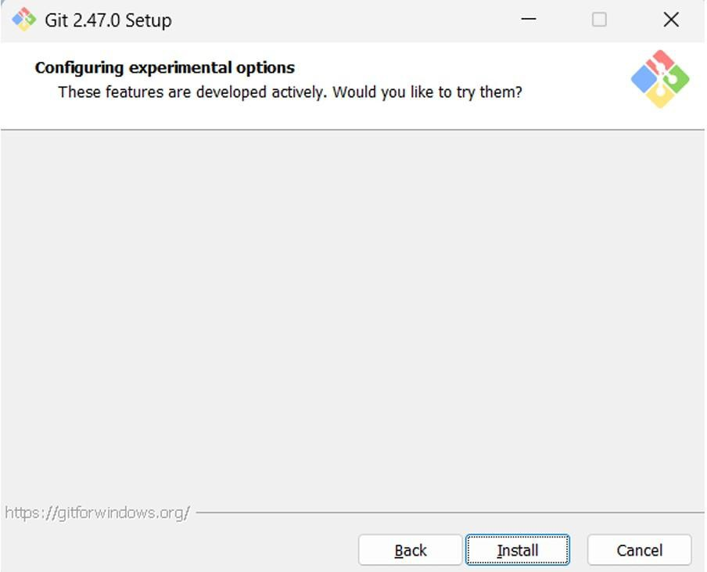

1. Click on Finish.

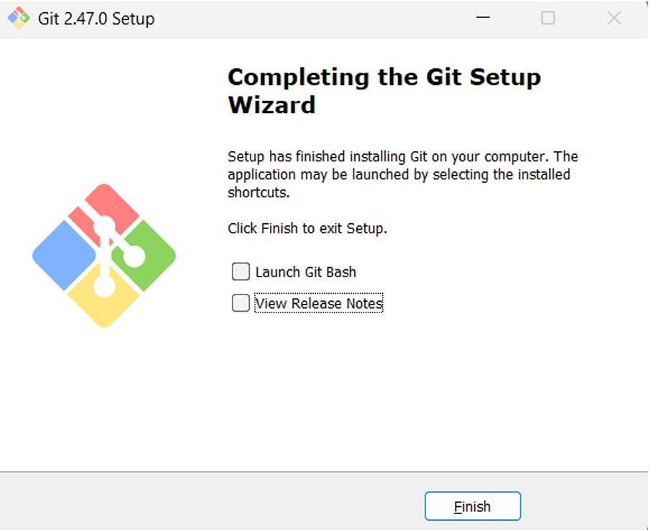

1. Verify Git Bash Installation using the command: git –version



1. Configure user details using the following commands: git config --global user.name "Your Name"

git config --global user. email "[your.email@example.com"](mailto:your.email@example.com).





# Practical No.: 2

**Aim:** Setting up GitHub Account and Adding Collaborators on GitHub Repository

## Theory:

Whenever you make a repository in GitHub, not everyone has the permission to change or push

codes into your repository. The users have a read-only access. In order to allow other individuals to make changes to your repository, you need to invite them to collaborate to the project. GitHub also restricts the number of collaborators we can invite within a period of 24 hours. If we exceed the

limit, then either we have to wait for 24-hours or we can also create an organization to collaborate with more people. Being a collaborator, the user can create, merge and close pull requests in the

repository. They can also remove them as the collaborator.

## Procedure:

1. Go to the link <https://github.com/>
2. Click on Sign in

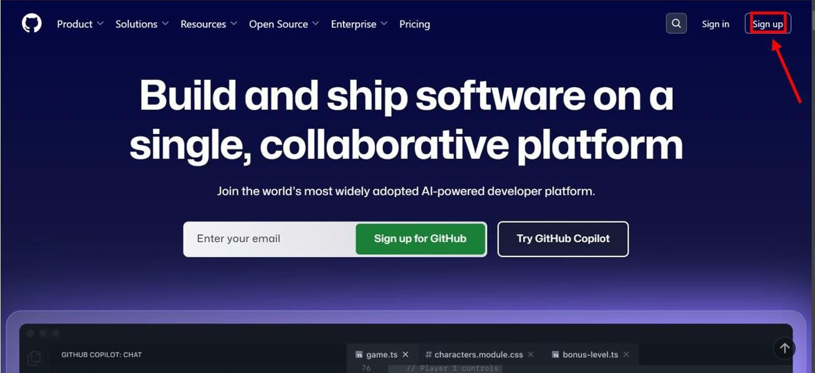

1. Login to your GitHub account and you will land on the homepage as shown below. Click on Repositories option in the menu bar.

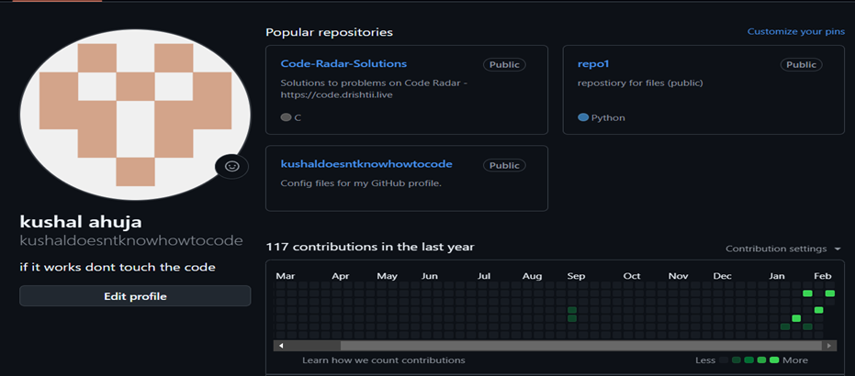

1. Click on the ‘New’ button in the top right corner.



1. Enter the Repository name and add the description of the repository.
2. Select if you want the repository to be public or private.

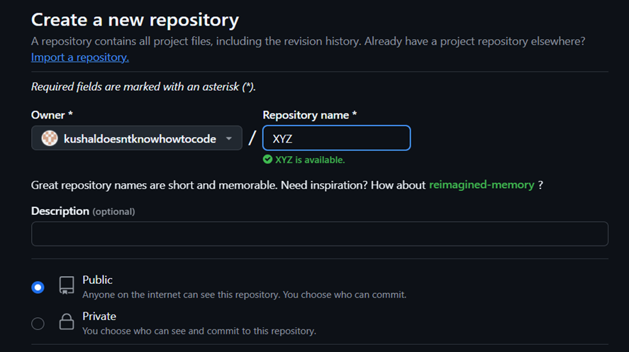

1. If you want to import code from an existing repository select the import code option.

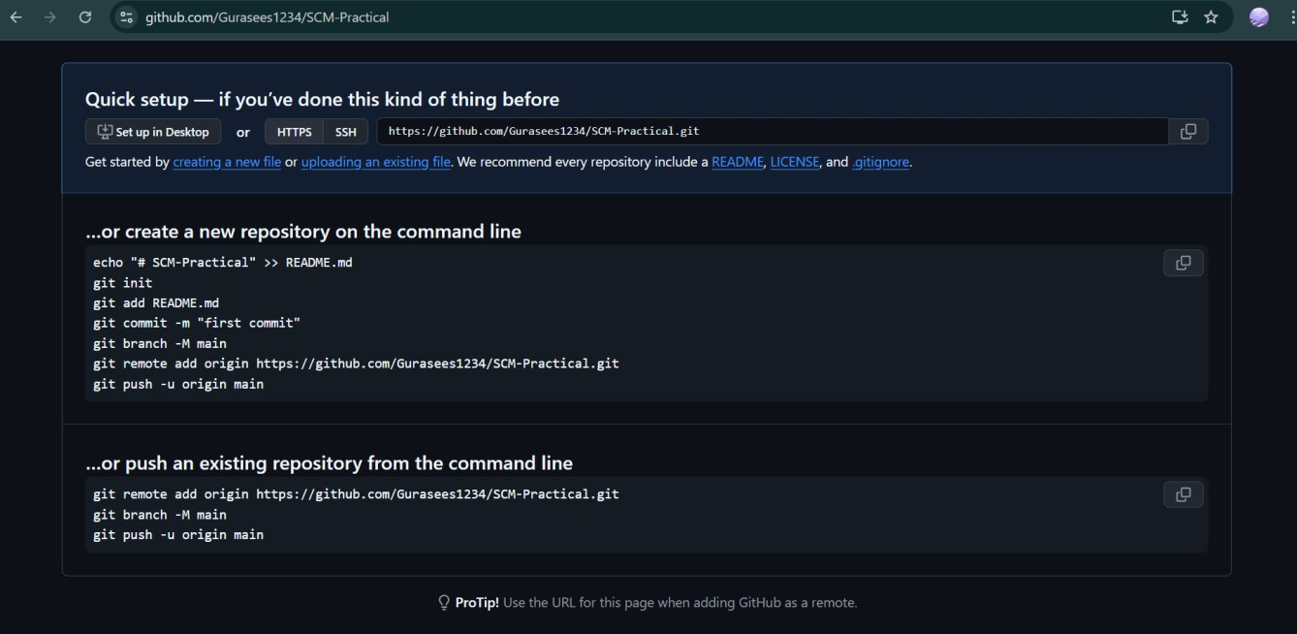

1. Now, you have created your repository successfully.
2. To add collaborators to your repository, open your repository and select settings option in the navigation bar.

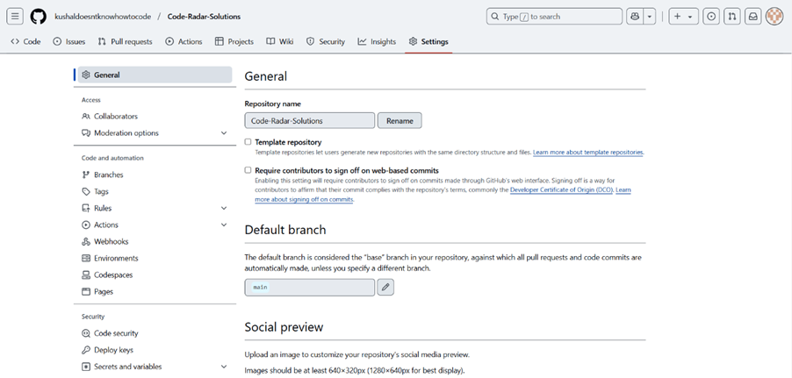

1. Click on Collaborators option under the access tab.
2. After clicking on collaborators, GitHub asks you to enter your password to confirm the access to the repository.

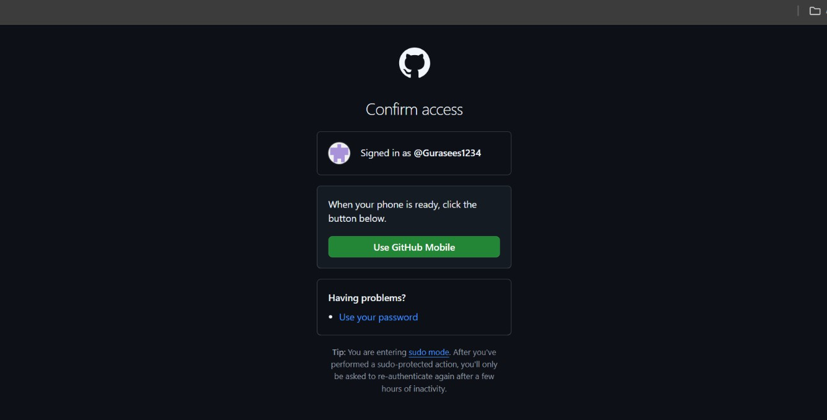

1. After entering the password, you can manage access and add/remove team members to your project.

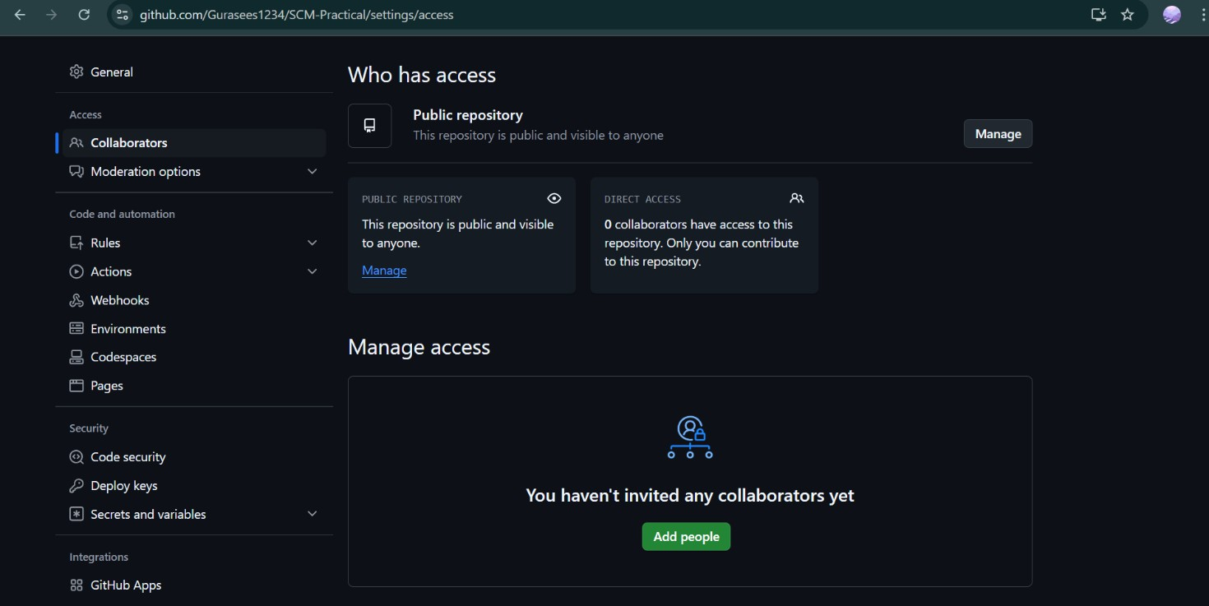

1. To add members, click on the add people option and search the id of your respective team member.

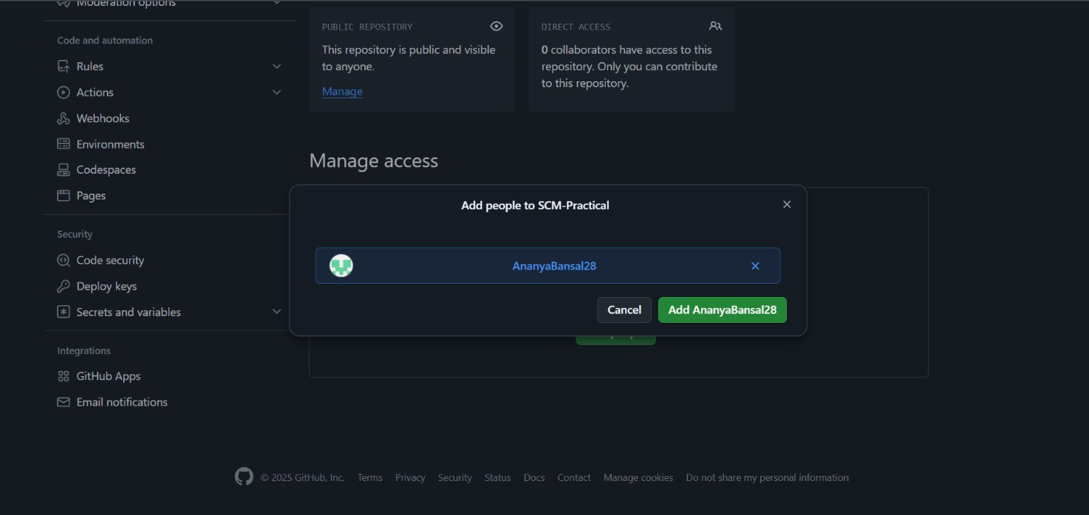

1. An email for the collaboration of the repository is sent to the user with whom collaboration is made.
2. Click on View Invitation to accept the collaboration invitation.
3. After Accepting the invitation, the shared repository is visible to the collaborator under ‘Repository’ section.
4. To remove any member, click on remove option available in the last column member’s respective row.
5. 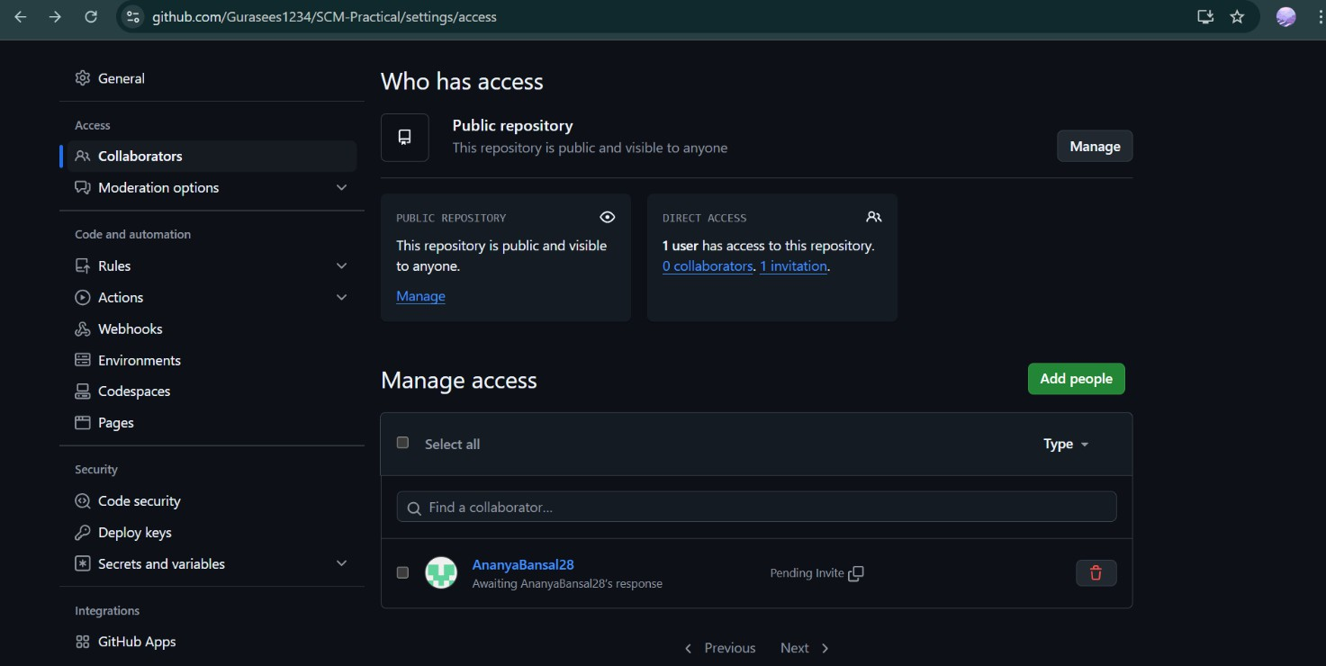Commit History by collaborator.

**Practical No.:3 Aim:** To merge two branches within a Git repository. **Theory:**

Merging branches in Git allows you to combine changes from one branch into another. It is a fundamental process in collaborative workflows, ensuring all contributions are

integrated into a single codebase.

## Procedure:

1. Create a new branch and switch to it.
2. Make changes to a file in the new branch and commit them.
3. Switch back to the previous branch.
4. Modify another file in the previous branch and commit the changes.
5. Merge the new branch into the master branch**.**
6. Modify another file in the previous branch and commit the changes.
7. Merge the new branch into the master branch**.**

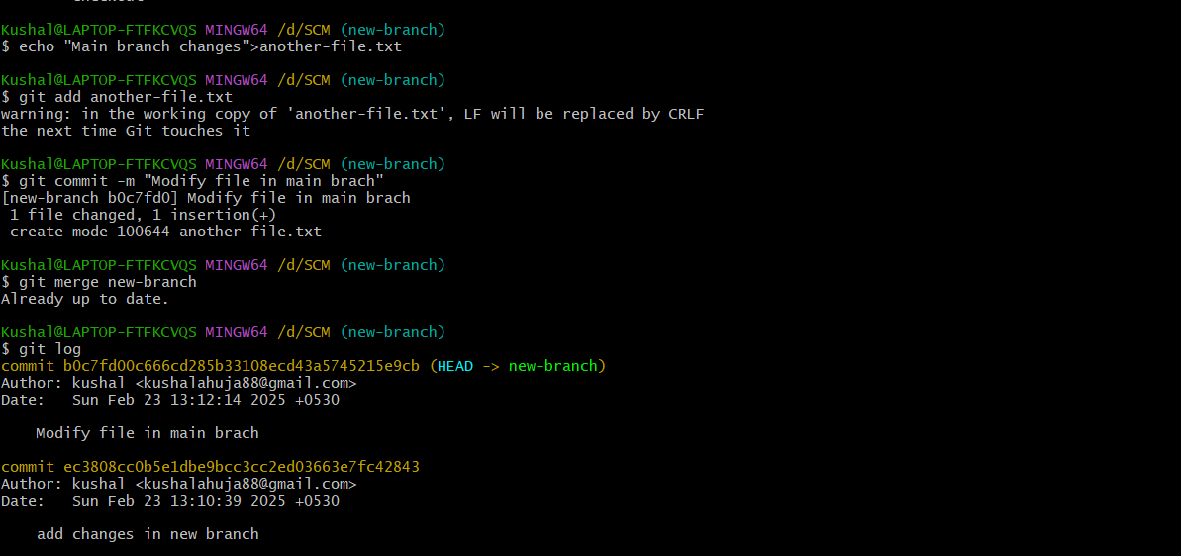

# Practical No: - 4

**Aim:** To demonstrate push and pull operations in Git.

## Theory:

Push transfers committed changes from the local repository to the remote repository, while pull retrieves updates from the remote repository.

## Procedure:

* 1. Make changes in the local repository and commit them.
  2. Push the changes to the remote repository using git push.

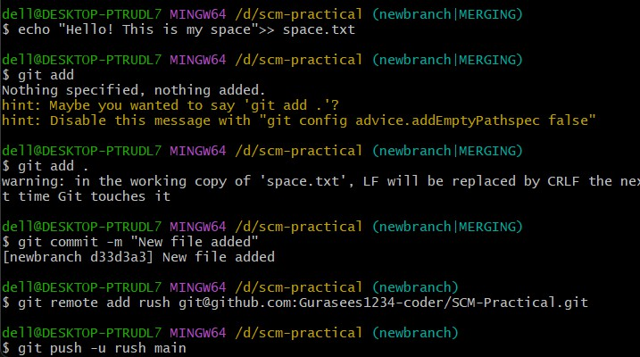

* 1. Make changes directly on the remote repository (e.g., via GitHub interface).

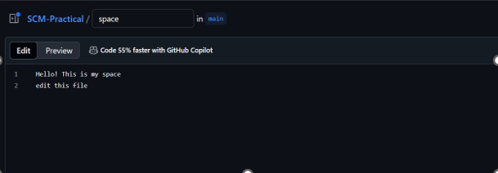

* 1. Pull the changes to the local repository using git pull.

